Wireshark Practical
Practical no 10
A. Capture all TCP traffic to/from Facebook, during the time when you log in to your Facebook account
MUST Create your own Facebook account
1. Open Wireshark on your system.
2. Select the active network interface (Ethernet or Wi-Fi).
3. Once selected, Wireshark will start capturing packets.
4. Log in to your Facebook account only after Wireshark is running. 5. Open the Command Prompt and run:
ping facebook.com this will give you Facebook address
(eg for my machine 163.70.144.35 / 157.240.237.35)
6. In Wireshark, apply a filter to capture only Facebook packets:
tcp && ip.addr == 163.70.144.35 (Facebook id)
7. To verify, open your browser and enter the same IP address. If it opens Facebook, you know the captured packets belong to Facebook.
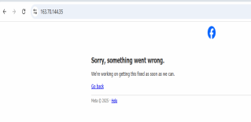
B. Capture all HTTP traffic to/from Facebook (other website), when you log in to your Facebook account
1. 1st you need to open http website like techpanda.org
2. you have to enter any sample email & enter password and click on submit
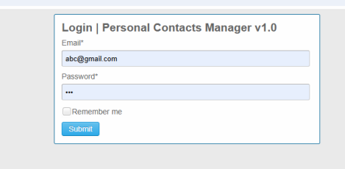
3. You will get
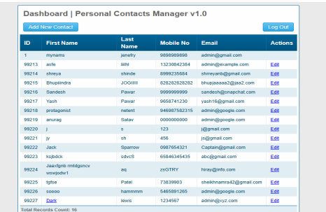
3. Open cmd and give command and ping techpanda.org then you will get connectivity with
5. http && ip.addr==10.30.74.132 (Machine IP) && ip.addr==271.174.153.52 (techpanda.org ip) (imp command )
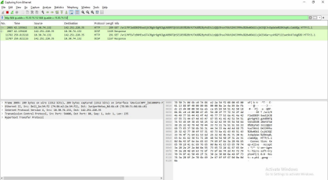
3 & 4. Write a DISPLAY filter expression to count all TCP packets (captured under item #1)
that have the flags SYN, PSH, and RST set. Show the fraction of packets that had each flag set.
tcp.flags.syn==1
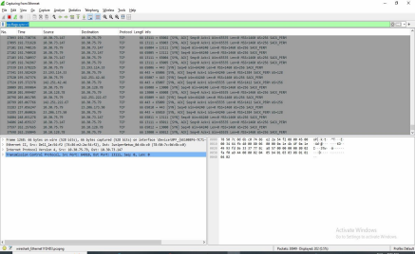
tcp.flags.push == 1
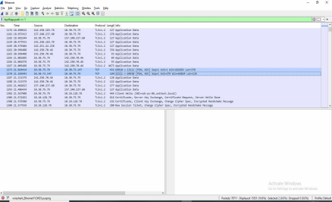
tcp.flags.reset == 1
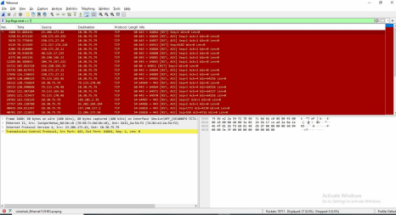

Here is a simple, short, easy explanation of what to do and what to write in your output file for the practical.

✅ A. PACKET CAPTURE USING WIRESHARK

(a) Capture TCP traffic to/from Facebook when you log in
Steps:
- Open Wireshark
- Select your active interface (Wi-Fi/LAN)
- Start capture
- Open facebook.com and log in
- Stop capture
- Apply display filter:
To show TCP packets to/from Facebook:
tcp && ip.addr == <Facebook_IP>

➡️ To find Facebook IP: Right-click any Facebook packet → "Apply as Filter → Selected" or check Server Hello SNI = facebook.com.
Save output:
File → Save As → facebook_tcp.pcap

Capture HTTP traffic to/from Facebook (or any other site)
Since Facebook uses HTTPS, not HTTP, do this with another website, e.g., example.com.
Filter:
http && ip.addr == <Website_IP>

Save as:
http_traffic.pcap

✅ B. DISPLAY FILTER FOR SYN, PSH, RST FLAGS AND COUNT THEM

Filter for SYN packets
tcp.flags.syn == 1 && tcp.flags.ack == 0

Filter for PSH packets
tcp.flags.push == 1

Filter for RST packets
tcp.flags.reset == 1

How to count
In Wireshark:
Statistics → Conversations → TCP → shows packet counts.
Or:
Apply filter → see count in bottom bar (Displayed: X)

✨ Write this in your output file (short answer):
Let Total TCP packets = T
Then compute:
- SYN fraction = (Number of SYN packets / T)
- PSH fraction = (Number of PSH packets / T)
- RST fraction = (Number of RST packets / T)
Example (you will fill actual values):
- SYN = 20 packets → 20/T
- PSH = 50 packets → 50/T
- RST = 3 packets → 3/T

✅ C. Count Facebook TCP vs HTTP packets

Count TCP packets to/from Facebook
Filter:
tcp && ip.addr == <Facebook_IP>

→ Note the count from Wireshark (Displayed: X)

Count HTTP packets to/from Facebook/other site
Filter:
http && ip.addr == <Website_IP>

→ Note count

What to write:
Example format (you will fill your own values):
Packet Type | Count
Total TCP packets to/from Facebook | ___
Total HTTP packets to/from Facebook/other site | ___
TCP packets sent | ___
TCP packets received | ___
HTTP packets sent | ___
HTTP packets received | ___

If you want, I can prepare the full practical file report for you (Aim, Procedure, Output screenshots, Conclusion) in ready-to-submit format.

